, with words at the top and bottom in large, upper case, bold black letters. The top of the circle reads, ‘A HAND UP NOT A HANDOUT.’  Under the circle, the words are, ‘GEORGIA COUNCIL OF THE BLIND.’

In the center of the circle is a pencil drawing in grey tones, of the palm of an open right hand cradling a Georgia peach. At its top, from the left side of a short brown stem, a thin green leaf hangs down and over the thumb. The peach has colors like the warmth of the sun. The vivid yellow and orange colors contrast with the black, upper case letters GCB in the middle of the

peach, with corresponding Braille dots directly under the three letters.

The GCB DIGEST

A publication of the Georgia Council of the Blind

An affiliate of the American Council of the Blind,

An organization promoting a hand up and not a handout.

Spring 2022

+++

This picture contains the following people:

Cecily Laney Nipper, Betsy Grenevitch, and her guide dog James, Marsha Farrow, and Kathy Morris.

GCB Officers for 2022:

Cecily Laney Nipper, GCB President, 470-218-7885, [roses828@comcast.net](mailto:roses828@comcast.net)

Marj Schneider, GCB First Vice-President, 912-352-1415, [marjschneider@bellsouth.net](mailto:marjschneider@bellsouth.net)

Judy Presley, GCB Second Vice-President, 706-878-2962, hoyal@windstream.net

Kathy Morris, GCB Secretary, 706-466-2253, mkumorris@yahoo.com

Marsha Farrow, GCB Treasurer, 706-859-2624, [marshafarrow@windstream.net](mailto:marshafarrow@windstream.net)

Betsy Grenevitch, GCB Member at Large Representative, 678-862-3876, [blindangel61@gmail.com](mailto:blindangel61@gmail.com)

Amanda Wilson, Digest Editor, 770-547-4700, [moonrocks@bellsouth.net](mailto:moonrocks@bellsouth.net)

Janet Parmerter, Assistant Editor, 551-247-1195, [Janet@ParmerTours.com](mailto:Janet@ParmerTours.com)

Table of Contents:

From Your Editor, by Amanda Wilson

GCB Presidential Message, by Cecily Laney Nipper

GCB Board meeting minutes from August 2021, by Betsy Grenevitch

GCB Board Meeting Minutes from November 2021, by Betsy Grenevitch

GCB Chapter News

Georgia Guide Dog Users News, by Marj Schneider

GCB Alliance on Aging and Vision Loss, by Alice Ritchhart

GCB Braille Project Committee, by Phil Jones

GCB Legislative Update, by Alice Ritchhart

GCB Membership Committee, by Amanda Wilson

GCB Community Phone Calls

Children Raised Around the Blind, CRAB, Courses, by DJ McIntyre

“Adam’s Accessible Airport Adventures,” Michelle Grenevitch

GCB Gear: Water Bottles and RFID

GCB Calling Tree: A Way to Connect with More GCB Members, by Mike Hall and Cecily Laney Nipper

GCB Ponder This, by Leah Streams

From Your Editor:

by Amanda Wilson

Hello, GCB family. We thank each one who has submitted articles in this issue of our magazine. If you have any change of address, telephone number, email address, or desired change of format, please inform our GCB treasurer.

Thanks to everyone who makes our GCB Digest such a considerable success. I particularly want to thank Janet Parmerter, Assistant Editor, for her editing skills and for the many hours she has worked on the magazine. I want to thank our President, Cecily Laney Nipper, for her presidential message with information about momentous events, legislation, and projects. I also appreciate the contributions from our new GCB Digest committee, each member who sent articles, and those who made suggestions.

From this point forward, please send any comments, articles, or messages to the GCB Digest Editor in Font: Arial, Font Style: Bold, Font Size: 16 (sixteen) point, Font Heading Size 20 (twenty) point, and please underline the Heading which will make things more consistent for reading and for Braille.

Note: The GCB Digest is now on NFB Newsline and on the Georgia Radio Reading Service, GARRS.

﻿

The Georgia Council of the Blind has a new Instagram account! Please check it out! To find it, search on Instagram for gacounciloftheblind. That represents ‘GA Council of the Blind’ without spaces and in all lower-case letters.

GCB Presidential Message:

by Cecily Laney Nipper

As the pollen announces that spring is on its way, New Horizons are advancing all the time in our community. As you will hear in this digest, the membership committee has been taking on projects, including collecting prescription eyeglasses for the Lighthouse in January, and raising money for the Multiple Choices assistive technology fund in Robin Oliver’s memory in February. During March, the legislative committee along with many members and allies of the Georgia Council of The Blind has been hard at work on several pieces of legislation.  
SB 108 was a journey. Blind day at the capitol, an event at which we invited our senators and congress persons to hear our voices on key issues, was held in February. Ten of our members were present in person, with a significant contingent of people attending online as well. This was our first experience with a hybrid day at the capital. Among the issues highlighted were accessible absentee voting and the commission for the blind. Graduate student, Tommy Woodyard, his mother, Mary Woodyard, and I had the opportunity to share our experiences with vocational rehabilitation. This was just the beginning of our journey with SB 108.  
It was later in February, on another visit to the Georgia capitol for a committee meeting where our bill would be considered, that I had my first opportunity to meet Senator Davenport, who has carried the commission bill in the Senate. After hearing from Georgia Council of The Blind Representatives about the great need for blind and visually impaired Georgians to be better represented by the vocational rehabilitation system which has failed us consistently, the committee delayed their decision. They wanted to hear from vocational rehabilitation. They expected VR to explain their inaction. After many efforts to contact VR, the committee was able to get a representative to come to a subsequent hearing where they could give their side of the story. The representative that attended the meeting was asked important question. “How many blind people are there in Georgia? “The answer reflected a number between 250,000 and 265,000 blind and visually impaired Georgians. The next question, “How many of these individuals with visual impairments are being served by Georgia Vocational Rehabilitation Services. “The crucial answer: 562 divided among six counselors. Those numbers tell the tale. The committee passed the commission bill into rules.  
Thanks to all your phone calls and emails to your senators, the commission bill passed out of rules and survived the throes of crossover day, passing into the Health and Human Services Committee. After a more than 10-year effort by long-time members of our organization, I hope and pray that this bill will pass in the House and become law. We cannot continue to be underserved. Please continue to watch for emails from Alice Ritchhart, legislative committee chair, with action items related to this critical issue.   
I can report a positive effort by Shirley Robinson of Georgia Vocational Rehabilitation. In collaboration with Dorothy Griffin, president of the national Federation of the Blind of Georgia and me, Shirley Robinson has planted the seed of what she is calling a job club. This monthly meeting will offer experienced speakers you can give advice to those seeking employment. The sessions will be for blind and visually impaired people only. Topics to be discussed will include how to prepare for an interview, how to interview on technology platforms, how to brainstorm how you will do the job for which you are applying. This program is still in its infancy, but I have hope that it will provide a leg up to some people who are going out into the workforce. we will see a survey coming out about this project. Please consider filling it out so that we can better evaluate the need and tailor the experience.  
Our board meeting on April 30 from 10:00 AM until 1:00 PM is on the horizon. At this meeting, a convention committee will be appointed to begin making plans for our fall convention. If you have items that you would like to be considered on our board meeting agenda, please contact me directly at [roses828@comcast.net](mailto:roses828@comcast.net) or via phone at 470-218-7885.   
On a national level, the legislative seminar including several days of instruction and workshops, which were held virtually. Our legislative committee members worked hard making appointments and meeting with our legislators at the national level to discuss the legislative imperatives that were chosen by the national office for this session. Thank you for all of your help. Stay tuned, stay safe and let’s move forward together.

Georgia Council of the Blind Board Meeting Via Zoom

by Betsy Grenevitch

Georgia Council of the Blind Board Meeting Via Zoom

August 21, 2021

Call to Order, President Alice Ritchhart:

Alice called the meeting to order at 10:01 AM.

Invocation, Sharon Nichols:

Sharon led us in our invocation.

Roll Call, Betsy Grenevitch:

Those present were: Alice Ritchhart, GCB President; Philip Jones, GCB First Vice-President; Jamaica Miller, GCB Second Vice-President; Betsy Grenevitch, GCB Secretary; Marsha Farrow, GCB Treasurer; Valerie Hester, GCB Member at Large Representative; Keith Morris, GCB Immediate Past President; Jerrie Toney, Athens Chapter; Deborah Lovell, Augusta Chapter; Cecily Laney Nipper, East Georgia Chapter; Judy Presley, Greater Hall County Chapter; Sharon Nichols, Northwest Chapter; Tonia Clayton, Rome Floyd County Chapter; Marj Schneider, Savannah Chapter; Amanda Wilson, The_GCB _Digest Editor and DJ McIntyre, Georgia Guide Dog Users.

Guests: Cecily Nipper, Sr.

President’s Report, Alice Ritchhart:

Some of the people now calling her are homeless and living in such places as hotels. She is also receiving calls from younger people who need services. There are still calls from those who are either not school age or 55 (fifty-five) and older looking for services. Chris Wells contacted her to let her know about some upcoming changes. The changes will affect the blind and the deaf-blind programs. Kay McGill will be retiring after December. The person taking her place will also be working with the deaf-blind clients. GCB will be represented on a committee to consult us concerning policies and things concerning counselors. They plan on having designated counselors for the blind. Each of the centers will have a counselor for the blind. Atlanta will have more than one counselor. Shirley Robinson has asked to be on the program for our upcoming conference and convention in November. An Update on ACB: Dan Spoone, our current ACB president, had major surgery so was not able to preside over the Constitution and Bylaws voting meeting. The conference and convention this coming summer will be hybrid. Everyone will have the right to vote electronically. ACB Resolutions and Constitution and Bylaws Changes: There will be a committee formed to work on how the voting will take place for resolutions and constitution and bylaws changes. There is ongoing discussion about whether we should continue having affiliate voting since everyone will be able to vote now. ACB Presidents’ Meetings: there are now regular meetings for state presidents of the state affiliates and the special interest affiliates every Wednesday. They also have an email list where the presidents are informed concerning valuable information. Cindy Hollis wants to begin an email list for all affiliate presidents on the local levels. Only the presidents are permitted to be on this list. She wants to begin monthly calls for this group and is willing to increase the number of calls if the group desires to do so.

Secretary’s Minutes, Betsy Grenevitch:

Betsy made a motion seconded by Jamaica that the minutes for the special called board meeting and the April meeting be approved as they were sent out and the motion carried.

Treasurer’s Report, Marsha Farrow:

In our main checking account, we have $8,082.98. Included in this total is $540.48 for the Youth Fund and $3,099.05 for the senior fund. This leaves us with a total of $4,443.45 for general expenses. GCB Conference Account: $1717.35

We received $1000 from Dr. Schivers to help with conference and convention expenses. Al and Cora Camp Scholarship Account: $119.91. Money will be moved to this account when we need it. GCB CD: $5,069.63. This CD will mature in October 2021. We originally invested $5 thousand in this account. GCB Long Term Investment Account: $16,258.06. This account matures in 2027. We received $371.77 interest in this account last year. Way Financial Investment: May: $71,223.69; June: $73,706.32; July: $72,211.37. We have paid 50% of the deposit for our conference and convention. We have also paid the web hosting fees. Phil made a motion seconded by Jamaica to file the treasurer’s report for audit and the motion carried.

Finance Report, Jerrie Toney:

The budget has been sent out to the board. The committee met on August 12 and there were not any questions from the members of the committee.

Membership Committee, Amanda Wilson:

We currently have 144 members. All chapters are meeting either in person, via Zoom or on the phone. We still have several phone calls taking place either regularly or sporadically. They include Betsy’s Braille call, Mike Hall’s Prayer and Praise call, Marsha’s Walking in the Sunshine call, DJ’s Fashion call, Alice’s Travel call, Mary Woodyard’s Game Night, and the Book Club call.

Amanda sent out an email to the chapter presidents asking them to contact all their members to check on them.

Personal Information for Potential Members or Those Who Need help, Alice Ritchhart: There is concern on the national level from different states about ACB National no longer sending information to the state concerning potential members or someone who might need assistance obtaining services. There is talk about adding a question on the membership form asking for permission to pass on information to a state affiliate. This year they had to designate one person who could be contacted with the potential new member information. Alice designated Amanda to be that person. This problem will be discussed at the upcoming ACB board meeting.

Technology Committee, DJ McIntyre:

DJ read Steve’s report. On their committee call they talked about the prototype for the GCB app for the IPhone and Android phone. This app will be able to provide push notifications to users about upcoming events. Sharon suggested adding a way to get connected to the GCB website. They also talked about adding a way for someone to be able to call someone with GCB. You will also be able to submit corrections to the database. The app has accessible features that reads the content. It has helpful hints for a user to be able to navigate the app. You can also use light or dark mode. The next step is to publish the site on the IOS app store and the Google Play store. We can obtain a free developer app account for GCB. Sharon volunteered to update and make corrections to the Blindness Resources data.

Digest Committee, Amanda Wilson:

They had a committee at the beginning of August. There was some discussion about wanting to add some more articles. They talked about doing recipes, interviews, and humorous articles. Our logo now appears on the _Digest. ACB now has an editor’s list, and they will also be having quarterly meetings. She invited anyone who is interested in helping on their committee to contact her. The next deadline for the _Digest is August 30.

Nominating Committee, Jerrie Toney:

They will be presenting the slate of officers at our reception on Friday during the conference and convention. The members of the committee are Jerrie Toney, Robin Oliver, and Steve Longmire. They have already reached out to some individuals and will be reaching out to more soon.

Constitution and Bylaws, Marj Schneider:

The Constitution and Bylaws were last updated in 2016. The committee has not met yet but will be meeting shortly. The members of the committee are Marj, Schneider, Phil Jones, and Brent Reynolds. One of the things they will be addressing is how the membership can vote.

Conference and Convention Committee, Cecily Laney Nipper, and Marsha Farrow:

Cecily and Marsha co-chair the committee. We will be having our conference and convention on November 12-13 at the Marriott Courtyard in Cartersville, Georgia. On Saturday, our meetings will be held at the Clarence Brown Conference Center. DJ and Cecily Laney Nipper will go to the building and make a map with descriptions of the buildings. On Friday afternoon there will be a tour of the Western History Museum. On Friday night we will have a reception at which we will be honoring Kay McGill for her service in the blind and visually impaired community. On Saturday there will be three sessions. One of the sessions will be talking about fraud scams. The second session will be presented by Democracy Live concerning accessible voting. The third session will be presented by Shirley Robinson who will be talking to us about the upcoming changes in vocational Rehab and letting us know who our specialized counselors for the blind throughout the state will be. The registration form should be coming soon. At Large, Betsy Grenevitch: There was not anything to discuss.

New Business

Special Interest Affiliates, Everyone:

Cecily explained to us that after her chapter meeting when they heard from Paul Edwards and Jane Corona about the Braille Revival League, she was wondering if there might be interest for us having an affiliate here in Georgia.

Alice expressed interest in starting an Alliance on Aging affiliate here in Georgia.

Marj suggested that instead of forming an affiliate with Braille Revival League that we form a committee to work on Braille projects. Forming an affiliate requires a lot of set-up documents. Phil spoke in favor of this idea.

Jamaica told us that the Library Users

of America would like for states to form affiliates under them.

Phil felt we need to find out if there is enough interest in the state to form an Alliance on Aging affiliate here in Georgia.

Marj made a motion seconded by Cecily Laney Nipper that GCB establish a Braille Projects committee and the motion carried. Cecily, Betsy, and Phil will be on this committee with Phil as the chair.

At Large Members: Valerie, Amanda and Betsy will work on how to keep in better touch with At Large members since the phone call does not seem to be working. Alice suggested that we form a phone tree and call them quarterly.

Brag and Steal

Tonia Clayton from the Rome Floyd County Chapter reported that they have met in person three times at restaurants. However, because of the increase in Covid, they are thinking about going back on the phone. In June, they had speakers from Triple A. In July and August, they just talked among themselves.

Jerrie Toney, from the Athens Chapter reported that they are still meeting by phone. ON some of the calls they have had speakers. Dorothy Griffin will be speaking to them about Newsline at their next meeting.

Phil Jones, from the East Georgia Chapter reported that They are meeting via Zoom and having speakers at their meetings. Dan Spoone spoke to them in May. In June they had someone speak to them about Medicare fraud. In August, they had Paul Edwards and Jane Corona speak to them about the Braille Revival League affiliate. They have now formed their own Braille Projects committee in their chapter. Cecily Laney Nipper told us that East Georgia meets on the GCB Zoom account.

Cecily offered to help any chapter set up meetings on a Zoom account and help them find a host.

Scholarship Committee, Marj Schneider:

Marj suggested that we may want to offer a first-time scholarship for an attendee to our conference and convention in November. This scholarship would include the price for the hotel, registration fee and their food during the conference and convention. Cecily made a motion seconded by Jamaica that the First-Timers scholarship be offered to include registration, a one-night stay at the hotel, and food during the conference and the motion carried.

Adjourn:

We adjourned at 11:35 AM.

Respectfully submitted by

Betsy Grenevitch, Secretary

Georgia Council of the Blind Board Meeting Minutes

by Betsy Grenevitch, Secretary

Georgia Council of the Blind Board Meeting via Zoom and In-Person

Saturday, November 13, 2021

Call to Order, First Vice-President Phil Jones:

Phil called the meeting to order at 3:08 PM due to the absence of President Alice Ritchhart. Phil told us that he really enjoyed serving as first Vice-President for the past two terms and that he would still be on the board for a little longer since he is now president of his local chapter.

 Invocation, Cecily Nipper, Sr.

  Cecily Nipper, Sr. led us in the invocation.

Roll Call, DJ McIntyre:

Those present were Phil Jones, First Vice-President, Betsy Grenevitch, Secretary, Marsha Farrow, Treasurer, Jerrie Toney, Athens Chapter, Deborah Lovell, Augusta Chapter, Cecily Laney Nipper, East Georgia Chapter, Judy Presley, Greater Hall Chapter, Tonia Clayton, Rome Floyd Chapter, Marj Schneider, Savannah Chapter, Tiyah Longmire, South Atlanta Chapter, Keith Morris, Immediate Past President, DJ McIntyre, GGDU, Amanda Wilson, Digest Editor and Steve Longmire, Webmaster.

Installation of Officers: Jerrie Toney and Robin Oliver:

Robin read the Oath for the new officers, and they repeated it after her. The officers installed were Cecily Laney Nipper as President, Marj Schneider as First Vice-President, Judy Presley as Second Vice-President, Kathy Morris as Secretary, Marsha Farrow as Treasurer, and Betsy Grenevitch as Member-at-Large Representative.

At this point our new president, Cecily Laney Nipper took over the meeting.

 Next Meeting:

Deborah Lovell made a motion seconded by Tonia that our January board meeting be a virtual meeting and the motion carried.

Correction from the Business Meeting, Cecily Laney Nipper:

The only new affiliate that we are looking to form is the Alliance on Aging and Vision Loss affiliate. We had a Braille committee chaired by Phil but there is no Braille Revival League chapter being formed at this time. The Braille committee will continue with Phil as the chair.

Adjourn:

Deborah Lovell moved and Cecily Nipper, Sr., seconded that we adjourn. We adjourned at 3:18 PM.

Respectfully submitted by

Betsy Grenevitch, Secretary

GCB Chapter News:

Athens Chapter:

The Athens chapter meetings are held on the phone on the fourth Saturday of every month at 10:30 AM. The call-in number is 605-313-4818 and the access code is 463476#. For More information contact Jerrie Toney at (706) 461-1013 or [jerriemt2@gmail.com](mailto:jerriemt2@gmail.com).

Augusta Chapter:

For more information, please contact Deborah Lovell at 706-726-4054, or via email at [lovell.d2000@gmail.com](mailto:lovell.d2000@gmail.com).

East Georgia Chapter:

The East Georgia Chapter reported that in January they welcomed long time GCB member Tom Ridgeway who presented on his decades of experience teaching Braille and his time spent in Switzerland working on a symposium on the Braille music code.

On Friday, January 7, 2022, Cecily Laney Nipper, and Tiffany Montalvo had the opportunity to go into a local school to speak with an elite group of third graders about Braille literacy month and the life of the visually impaired. The students were eager to ask questions and learn.

At their February meeting several members shared their favorite recipes they enjoy preparing including corn casserole, cheesy apple bacon brunch, chocolate poke cake, cornbread pudding, fresh apple cake, Nutella stuffed chocolate chip cookie pie, and red salsa dip for chips. AT their March meeting was held a week earlier than normal. They held a discussion on the upcoming legislation SB 108 - a bill to create a commission for the blind to manage rehabilitation for blind adults and seniors to replace the current vocational rehabilitation that does not specialize in blind people and therefore provides a substandard service. For recipe information contact Linda Williams via email [lmwilliams1951@gmail.com](mailto:lmwilliams1951@gmail.com). The East Georgia Chapter meetings are held on the second Saturday on Zoom from 10:00 AM, until 12:00 PM. For more information about the East Georgia Chapter, please contact Phil Jones at 770-713-3306, or via email at [Brilman1952@gmail.com](mailto:Brilman1952@gmail.com). You can connect with East Georgia Chapter on Instagram at eastgachapter or on Facebook East Georgia Chapter of the Georgia Council of the Blind

Greater Hall County Chapter:

The Greater Hall County Chapter reported that in January their guest speaker was Nathan Coffin with Medicare Senior Outreach. He talked about how to prevent being scammed. In February, Cecily Laney Nipper, GCB President, visited our meeting along with her parents and spoke a few words. We welcomed Breneau University students from the Republic of Panama. A local University of North Georgia student gave an informative and encouraging talk. He answered questions from everyone--in English and in Spanish. We supported our own Jeremy Adams and Dawn Adams by purchasing Girl Scout cookies from their daughters. Don Linnartz celebrated his 90th birthday with a drop-in reception on Saturday, February 12, 2022. In March, Paige Thompson, Hall Voting Director, demonstrated the Handicapped Accessible voting machines and answered questions before the 2022 election season begins. Fay R. Loggins, an attorney in the Gainesville area for almost 50 years, passed away on February 10, 2022. Throughout his life Mr. Loggins was active in and served on several boards that advocated for and assisted the visually impaired and physically disabled. He was a charter member of the Greater Hall County Area Chapter of the Visually Impaired when it formed as a chapter of the Georgia Council of the Blind. Most recently, Mr. Loggins was appointed to the board of the Georgia Vocational Rehabilitation Association by former Georgia Governor Nathan Deal, a position Mr. Loggins held for several years. Among other local charities, Memorial gifts in Mr. Loggins’ memory have been donated to the Greater Hall Chapter for visually impaired children’s summer camp. We congratulate former member, Timothy Jones, as he has accepted a position with the Library of Congress in Washington, D.C. Timothy began his job in February. Our chapter meets on the second Saturday of each month at Smoky Springs Retirement Residences, which is located at 940 South Enota Drive, in Gainesville, Georgia 30501. For more information, please contact Judy Presley @ 706-400-2185 or via email at [hoyal@windstream.net](mailto:hoyal@windstream.net).

Northwest Georgia Chapter:

The Northwest Georgia chapter meetings are held at 1PM on the second Tuesday of the month at the Bank of Lafayette Community Center which is located at 104 North Main Street in Lafayette, Georgia. For more information, please contact Sharon Nichols.

Rome Floyd County Chapter:

The Rome Floyd County Chapter meetings are held on the third Tuesday, at different restaurants in Rome at 5:00PM. For more information, please contact Amanda Wilson at 770-547-4700, or via email at [moonrocks@bellsouth.net](mailto:moonrocks@bellsouth.net).

Savannah Chapter:

For more information, please contact Marj Schneider at 912-352-1415, or via email at [marjschneider@bellsouth.net](mailto:marjschneider@bellsouth.net).

South Metro Chapter:

The South Metro Chapter meetings are held on the second Tuesday at 6:30 PM, at the Piccadilly Cafeteria, which is located at 2000 Crescent Center Boulevard in Tucker, Georgia. For more information, please contact Brent Reynolds at 404-814-0768, or via email [jbr53@samobile.net](mailto:jbr53@samobile.net).

Georgia Guide Dog Users News

by Marj Schneider

For more information, contact Marj Schneider, 912-352-1415 or via email at [marjschneider@bellsouth.net](mailto:marjschneider@bellsouth.net).

GCB Alliance on Aging and Vision Loss.

GCB’s New Young at Heart Affiliate

Some of us in GCB are growing older, but we are still engaged. In April at the GCB board meeting, we will be submitting the necessary documentation to begin a new special interest affiliate known as the Alliance on Aging and Vision Loss.

What is the Alliance on Aging and Vision Loss? It is a special interest affiliate whose members are fifty-five and older or anyone who wants to be involved with us youthful folks. We will be meeting quarterly once we get established. Our dues will be $10 annually. Our mission is to educate and provide peer support to individuals who have had a vision loss later in their lives as well as helping their families to understand vision loss after 55. Our mission is also to provide social activities for our generation to keep us active and just to show that we still know how to have fun. So, if you want to be a part of a young new organization, we will be meeting the 3rd Monday of each quarter. You will learn, have the chance to help others your age, and just have fun. If you have any questions, please contact Alice Ritchhart at 912-996-4213, or via email at [alice.ritchhart@comcast.net](mailto:alice.ritchhart@comcast.net).

GCB Braille Project Committee

by Phil Jones

At the GCB board meeting in August of 2021, Alice Ritchhart, GCB past president, appointed a Braille Projects Committee. The purpose of which is to educate people about and promote the use of Braille. We had our first meeting last October.

We meet bimonthly on the first Tuesday at 7 p.m. Our first project was purchasing and distributing Braille Alphabet cards to schools.

Some of our committee members also talked to teachers and students about Braille. In the next few months, we hope to produce Public Service Announcements about Braille which we will distribute to broadcast and other media outlets. Members of the GCB Braille Project Committee are chair Phil Jones, Cecily Laney Nipper, Betsy Grenevitch, Judy Presley, Debora Lovell, and Sharon Nichols. For more information about the Braille Projects Committee contact Phil Jones at 770-713-3306 or via email at [Brilman1952@gmail.com](mailto:Brilman1952@gmail.com).

GCB Legislative Update

by Alice Ritchhart

The Georgia Council of the Blind (GCB) has been terribly busy this legislative session, and excited about the milestones we have had. The session began with GCB hosting its first hybrid blind day at the capitol. Some members and legislators came together in person at the capitol, and some members and legislators joined us by zoom. We had a presentation from Democracy Live to talk about absentee voting by using electronic accessible absentee ballot system. Our hope was that we could get a bill sponsored so the blind and other disabilities could vote independently and privately. We had a representative who had a bill written up, but for her to drop the bill she needed bipartisan support. Unfortunately, this did not happen, and so we will have to try again next year for accessible absentee voting. The other bill GCB accepted again this year was the Commission for the Blind bill. The bills were held over from last year in committee. The House bill HB468 again went nowhere. However, I am excited to report that the Senate bill SB 108 made it out of committee and went to the Senate floor vote on crossover day. It is the first time the bill has gotten that far. It did not stop there though. The bill went to a new committee to State Planning and Community Affairs Committee. Surprise and hope are still happening with the bill as it passed out of the community the 23rd day of March. The bill is now in Rules waiting to be voted on to go to the House floor for a final vote. After 10 years of challenging work by many in the blind community we may be successful in getting a Commission for the Blind. Many thanks go to President Cecily Nipper, DJ McIntyre, and Betsy Grenevitch for their making the necessary trips to the capitol to speak at the hearings when the bill was discussed. Also, the membership needs to be thanked for your quick response in making calls to the legislators to ask that they support the bill. Not only have we been busy working on state legislation many of our committee members took part in the ACB legislative seminar and day on the hill in D. C. to work on issues that can have a significant impact on all of us. The day in D.C. was a virtual event again this year. Our members reached out to many reps from Congress, and our two Senators. The national imperatives included accessible out of the box durable medical equipment, such as talking glucometers, insulin pumps, and at home Covid test as examples. The other imperatives were accessible exercise equipment as part of the get up and get moving campaign. These two issues have bill numbers. The last two issues ACB is still looking for sponsors. They are accessible internet websites, and an amendment to the Telecommunication Act for more video description and independent pass through so we do not have to share with the Spanish on the SAP. So, as you can see 2022 has been an active year for the legislative committee, and it is not over. Stay tuned and be ready to make calls to your legislators on all these issues. Hopefully in the next Digest we will be able to celebrate a victory with a Commission for the Blind.

GCB Membership and Project Committee Report

by Amanda Wilson

The GCB Membership Committee reports that in January, we collected eighty-four glasses for the Lighthouse for the Blind.

In February, we are sorry that Robin Oliver passed away. We invited all GCB members to contribute to a fund for assistive technology in her name.

In March, we discussed having an event on the ACB Community to inform other about what GCB is all about.

If you have any ideas for more projects or wish to be on the membership committee, please contact Amanda Wilson at 770-547-4700, or via email at [mmoonrocks@bellsouth.net](mailto:mmoonrocks@bellsouth.net).

GCB Community Phone Calls:

The Georgia Council of the Blind is holding community phone calls. The phone number for all the GCB community calls is

1-605-562-0400, and the access code is 780-5751, followed by the pound sign. If you cannot get in, then use the alternative phone number. It is 1-717-275-8940 and the access code is 7805751, followed by the pound sign.

Here is the schedule for GCB community phone calls.

Reading with Touch:

Betsy Grenevitch will discuss all things associated with Braille. This call will be on the second Monday of every month at 7:00 pm.

Praise and Prayer:

Mike Hall will lead us in praise and prayer on the third Tuesday of the month at 7:00 PM.

GCB Book Club:

Debra Lovell and Judy Presley will lead the monthly book club on the fourth Thursday at 7:30 PM.

Since the Covid epidemic, our GCB book club has been active for several months and we have read a wide variety of books. These include fiction, nonfiction, as well as biographies. Sometimes when you read a delightful book, you feel like you just must share it with others. This is what makes book clubs so much fun. That is why we encourage our members to suggest their favorite books and would love to have other book lovers out there to join us. We meet the fourth Thursday of each month at 7:30.

Trivia Game Night.

Mary Woodyard will lead us in trivia games on the fourth Monday of the month at 7:00 PM.

Children Raised Around the Blind, CRAB, Courses

by DJ McIntyre

Are you frustrated with the lack of training people have regarding people with visual impairments? Would you like to be able to share free resources with places of business you frequent to help them understand how to help you? Do you often find it difficult having to train staff over again? CRAB Children Raised Around the Blind is proud to announce their new online courses. All courses will be FREE for 2022! They have already launched How to Interact with a Visually Impaired Person. This course covers the basics with definitions to commonly used terms, most common eye diseases, and basic ways to help and include a person with visual impairments. By May 1st. They will add a course on how to guide (sighted, lead with a guide dog, and give directions), as well as basics for sharing media (PowerPoints, social media pictures, and other) and make it accessible. If you are interested in sharing or taking these courses, you can check out [www.childrenraisedaroundtheblind.net](http://www.childrenraisedaroundtheblind.net)/lp-profile/

Or you can email DJ McIntyre at [dgrenevitch@gmail.com](mailto:dgrenevitch@gmail.com) with your mailing address so she can mail you some business cards to the course that you can hand out when you run into problems.

Adam’s Accessible Airport Adventure

Written By: Michelle Grenevitch

The purpose in authoring this book is to help readers see accessibility particularly in the Hartsfield-Jackson Atlanta International Airport. I wanted everyone to be able to see that with a little help public areas can be accessed by people with disabilities.

Readers of all ages can learn to notice the trivial things in life through this adventure. Whether it is through the words or the illustrations, details are the key.

Throughout the book you will find key accessibility and disability vocabulary underlined. Definitions for these vocabulary words can be found at the end of the story.

There are two book options: $25- 1 copy of print book and one copy of braille only book (these are separate and will ship separately; OR $40- Print/Braille book

You can also buy the Large Print book on Amazon: <https://www.amazon.com/Accessible-Airport-Adventure-Michelle-Grenevitch/dp/0578249839>

You can send orders to Betsy Grenevitch at [blindangel61@gmail.com](mailto:blindangel61@gmail.com) or by calling 678-862-3876

Payment can be made by check to: Betsy Grenevitch 3463 Saddlebrook Drive Loganville, GA 30052

Or via PayPal: [blindangel61@gmail.com](mailto:blindangel61@gmail.com)

Michelle Grenevitch and The Northwest Georgia Chapter of the GCB gave Lucas Montalvo, from the East Georgia Chapter, a braille copy of Michelle’s book “Adam’s Accessible Airport Adventure”

The story entails young Adam’s journey through the airport meeting various individuals with different disabilities and how the airport is accessible to them. Accessibility for the disabled is unfortunately a struggle most of the time in most places. Through the story, it is possible to see how easy it is to limit that struggle with just a little help and some changes.

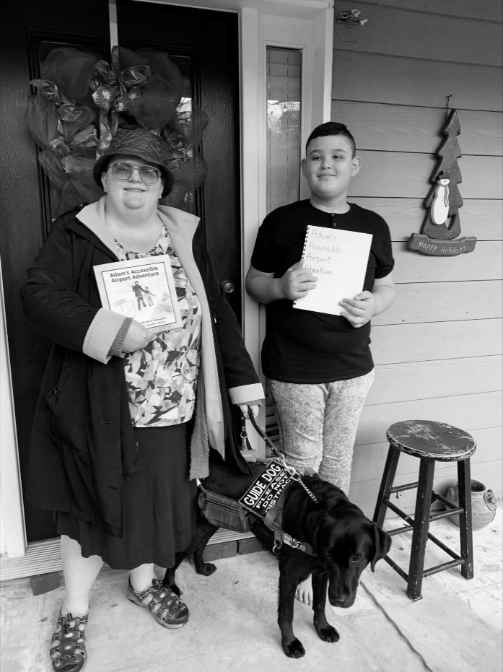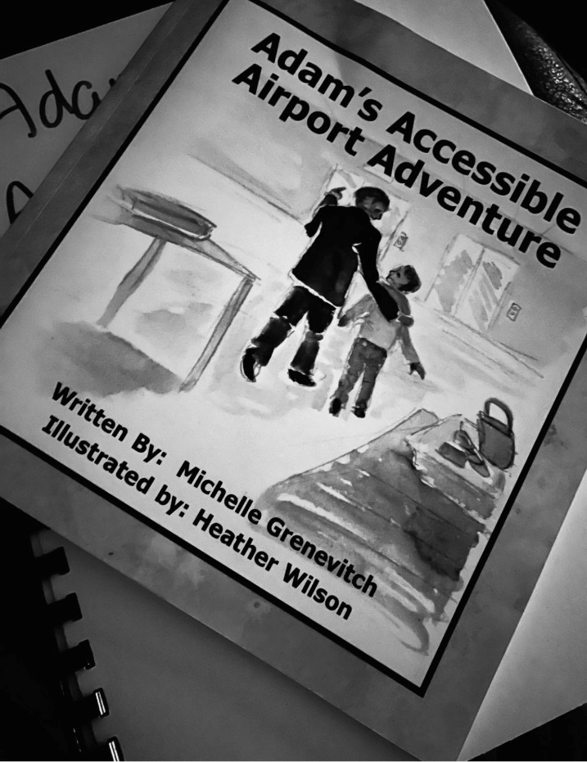

 First image GCB president Laney Nipper (Left), guide dog Shadow (center), East Georgia Chapter’s associate member Lucas Montalvo (right) - standing in front of black door with red wreath and holding a print and braille copy of “Adams Accessible Airport Adventure.”

Second image the front cover of the book - young Adam walking with older man in airport with the title Adams Accessible Airport Adventure across the top.

GCB Gear

Help us sell our GCB gear:

GCB Water bottles

These water bottles hold 20 oz of your favorite beverage! They are white with a black screw on lid with a pull up spout. GCB’s logo is in black and white. GCB logo is a circle around the top it reads: a hand up not a handout. Around the bottom: Georgia Council of the Blind. In the middle: a hand is sitting palm upholding a peach. Inside the peach is GCB in both print letters and Braille dots. $5 each.

RFID Cases

These cases will protect your cards from any potential card thefts where they can walk by using a device that gets your cards information. This card case is a denim-colored fabric. This case has one side pocket and a key ring inside. This will hold 5-8 cards on average. $10 each.

Flat rate shipping is $3 per order. You can pay via PayPal and note the number of items or send checks to Marsha with your request.

Calling Tree: A Way to Connect with More GCB Members

by Mike Hall and Cecily Laney Nipper

The pandemic and all the response to it has certainly brought some changes to the Georgia Council of the Blind and the way we function. We held our first virtual convention and then our first hybrid convention. Board meetings are now held virtually, and several chapters are still meeting virtually using either the Zoom platform or Conference Call. Along with our website and Facebook page, the Georgia Council of the Blind now has a google groups for Georgia Council of the blind members, an Instagram account and a Georgia Council of the Blind app for iPhone and Android. With all this modern communications technology, are we still leaving some folks behind?

There are any number of reasons why people do not use technology. A learning curve exists for folks who have not used computers. Those computer users who lose their eyesight later in life have a challenge adjusting to using the computer, learning to rely on a screen reader and replacing the mouse with keyboard commands. Whatever keeps folks from the latest technology should not prevent them from being involved and a vital part of GCB. How to reach people who are not using technology has been a concern for the American Council of the Blind and it is being discussed by Cecily Laney Nipper, GCB President, and others within the Georgia Council of the Blind. One emerging idea is to have a calling tree with members making calls to their fellow members who do not have email addresses listed. Cecily Laney Nipper has found that our state membership has eighteen people who do not have email. The number could be larger when you consider that some people listing email addresses do not regularly check their email messages. Beginning with the eighteen members Cecily has identified, it is possible to have each of these members contacted by telephone on a regular basis. It would be important to call these members to let them know about a community call, an upcoming vote in Georgia's general assembly, or a board meeting. Most importantly, these phone calls could be an opportunity to find out how each individual member is doing and to learn about their concerns and interests. Without identifying the eighteen members we hope to contact let us use some familiar names to consider an example of how this calling tree could work. For example, Cecily Laney Nipper could call Marj Schneider, Kathy Morris and Marsha Farrow. Marj Schneider could call Judy Presley, Betsy Grenevitch and Steve Longmire. Marsha Farrow could call Amanda Wilson, Phil Jones, and Jamaica Miller. Six people could make three phone calls each and all eighteen folks would be reached. If you would like to participate in this calling tree or share ideas as to how it could work, please contact Cecily Laney Nipper, GCB President, at 470-218-7885. For much of the history of GCB, the internet, email, and smart phones were not available. The old-fashioned telephone and snail mail were generously used. Could it be that old fashioned telephone could work for us again? When you think about it, a good phone conversation can generate thoughts and ideas that may be missed in an email exchange. Let us give old technology a try and see what happens.

Ponder This

by Leah Streams

We walk through darkness with strong inner beacons.

So, we can find our way.

Our wandering eyes try to search for something,

But find emptiness at bay.

They may start moving without man’s control.

It may leave some forlorn.

We simply cannot make them stop,

So do not look at us with hateful scorn.

Some of our eyes can see some light,

Others, not at all.

But if you see inside as we do,

You have seen it all.

The biggest pro of being sightless,

Is that we have learned to see

The glow that shines within, beyond

Superficiality.

So, reconsider,

And you will find

That you can see things

Through the eyes of the blind.

The End